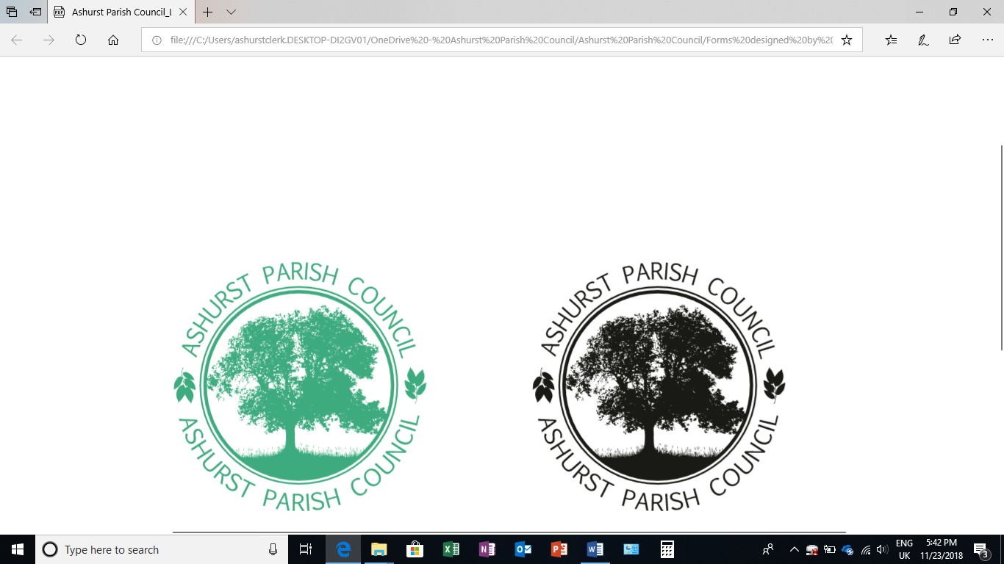 | Clerk to the Council: Emily Simpson  Tel: 07881714526  e-mail: ashurstclerk@outlook.com

TO: ALL MEMBERS OF ASHURST PARISH COUNCIL
Councillors are respectfully summoned to attend the Meeting of Ashurst Parish Council on Thursday 14th November 2024 at 7.30pm at Ashurst Village Hall for the transaction of the business on the Agenda below.
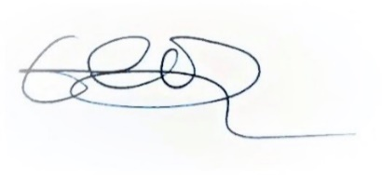
Emily Simpson
Clerk to the Council
8 th November 2024

AGENDA
- Apologies for Absence
To accept apologies for absence

- To Receive Declarations of Interest, Notification of Changes to Members’ Interests and consider any requests for a dispensation
To receive any declarations of interests from Members in respect to items on the agenda.

- Public Session (members of the public may speak for up to 5 minutes at the discretion of the Chair about items on the agenda).

- Approval of the Minutes of the Parish Council meeting held on 19th September 2024*
To review and approve.

- District Councillor Reports
To receive any reports.

- Conservation and Biodiversity Initiatives
To consider our next steps regarding Biodiversity and Climate Change initiatives.

- HALC Update
To receive any HALC updates.

- Planning Applications
- To discuss any planning applications received since the publication of the agenda

- Planning Decisions from HDC
To receive decisions on planning applications from Horsham District Council.

- Planning Appeals
To consider any appeals

- Payments and bank reconciliation *
- Review and approve the schedule of payments and bank reconciliation since the last meeting (19th September 2024).
- To discuss a contribution to the village newsletter, mini bus and Steyning swimming pool.
- To discuss the purchase of a new grit bin.

- Recreation Ground
- To receive a report on the Recreation Ground Trust’s income and expenditure since the meeting on 19th September 2024*
- To review the annual playground inspection and consider any necessary works*
- To receive an update on the rebuild/replacement of the John Eaton Hut
- To receive an update on the Oak Tree
- To receive an update on Ashurst Football Club

- Speeding in Ashurst
- To receive an update from Speedwatch
- To discuss the proposed purchase of a Speed Indicator Device (SID)

- Budget*
To consider a draft budget for 2025/26

- Meeting dates
To agree meeting dates for 2024.

*Documents have been sent to councillors with the Agenda

