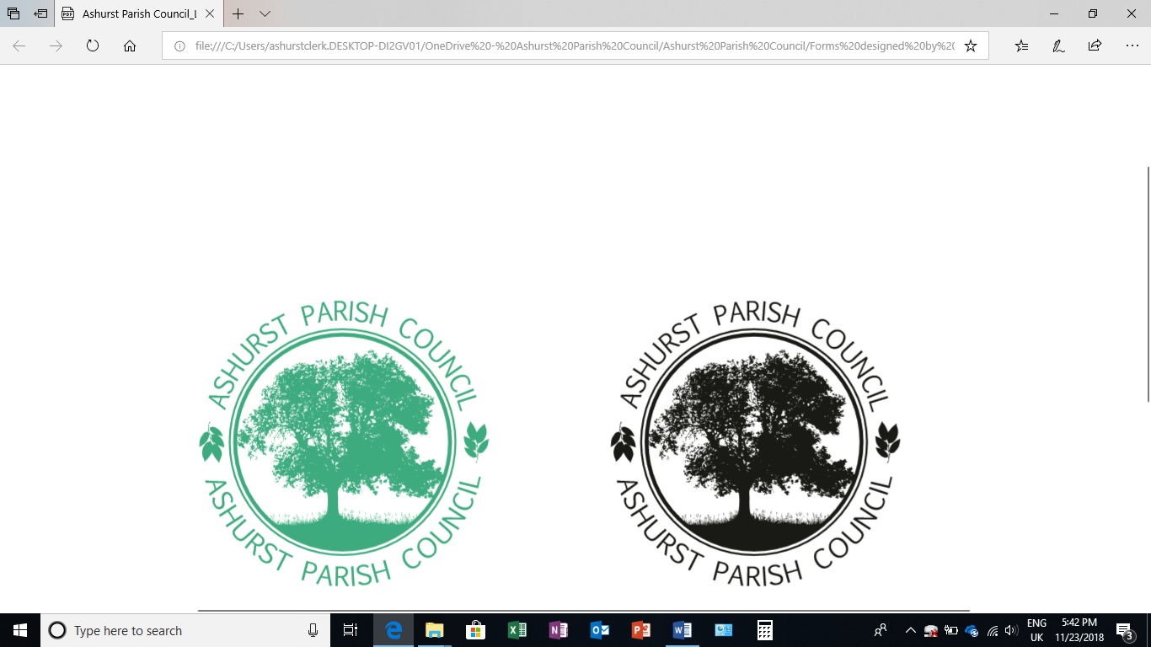 | Clerk to the Council: Emily Simpson  Tel: 07881714526  e-mail: ashurstclerk@outlook.com

TO: ALL MEMBERS OF ASHURST PARISH COUNCIL
Councillors are respectfully summoned to attend the Full Council Meeting of Ashurst Parish Council on Thursday 19th September 2024 at 7.30pm at Ashurst Village Hall for the transaction of the business on the Agenda below.
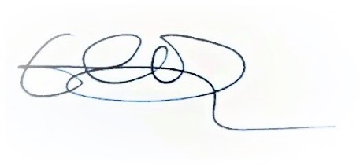
Emily Simpson
Clerk to the Council
13th September 2024
AGENDA
- Attendance and Apologies for Absence
To accept apologies for absence.
- To Receive Declarations of Interest, Notification of Changes to Members’ Interests and consider any requests for a dispensation
To receive any declarations of interests from Members in respect to items on the agenda.

- Public Session (members of the public may speak for up to 5 minutes at the discretion of the Chair about items on the agenda).

- Approval of the Minutes from the Full Council meeting held on 11th July 2024*
To review and approve the minutes.

- District Councillor Reports
To receive an update from the District Councillors.
- Conservation and Biodiversity
To discuss possible conservation and biodiversity initiatives, with a view to adopting an APC Biodiversity Plan. To be introduced by Cllr Knight.

- Recreation Ground
- To receive a report on the Recreation Ground Trust’s income and expenditure since the last meeting (11th July).*
- To receive an update on the rebuild/replacement of the John Eaton Hut.

- HALC Update
To receive an update from one of the HALC representatives.

- Planning Applications
- To review any planning applications received since the publication of the agenda

- Planning Decisions from HDC
To receive decisions on planning applications from Horsham District Council.

Parish: Ashurst PC Application Number: DC/24/0180 Site: Ford Farm Ford Lane Ashurst West Sussex BN44 3AT Description: Change of use from 3 farm buildings to B8 storage (Retrospective). Decision: Application Refused Date of Decision: 14/08/2024

- Payments and bank reconciliation
- To review and approve the schedule of payments and bank reconciliation since the last meeting (11th July).*
- To consider a grant request of £150.00 from the Steyning Responders.
- To appoint an internal auditor for the 2024-25 Council year.

- Speeding and Speed Indicator Devices (SIDs)
To receive an update from Councillor Nicholson and to confirm location points for the SIDs.

- Correspondence

Next meeting date: 14th November at 7.30pm.

*Documents circulated with the agenda

