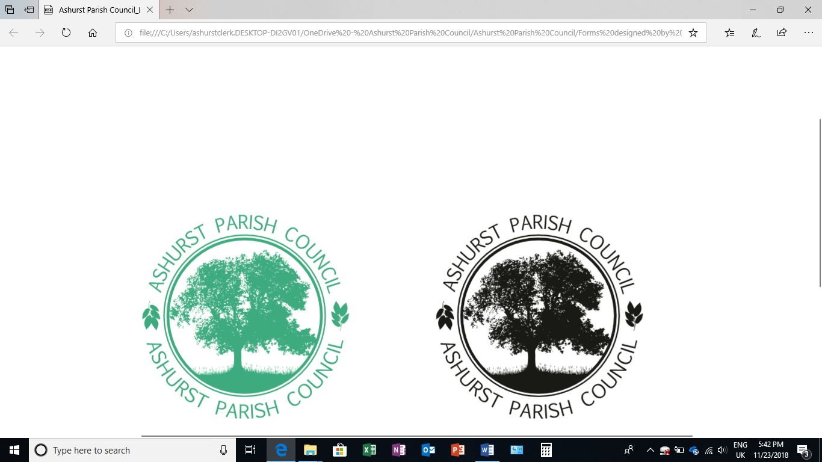 | Clerk to the Council: Emily Simpson  Tel: 07881714526  e-mail: ashurstclerk@outlook.com

TO: ALL MEMBERS OF ASHURST PARISH COUNCIL
Councillors are respectfully summoned to attend the Meeting of Ashurst Parish Council on Thursday 16th January 2025 at 7.30pm at Ashurst Village Hall for the transaction of the business on the Agenda below.
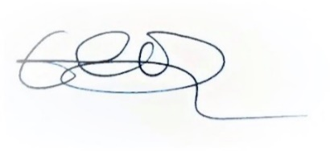
Emily Simpson
Clerk to the Council
11th January 2025

AGENDA
- Apologies for Absence
To accept apologies for absence.

- To Receive Declarations of Interest, Notification of Changes to Members’ Interests and to consider any requests for a dispensation
To receive any declarations of interests from Members in respect of items on the agenda.

- Public Session (members of the public may speak for up to 5 minutes at the discretion of the Chair about items on the agenda).

- Approval of the Minutes of the Parish Council meeting held on 14th November 2024*
To review and approve.

- District Councillor Reports
To receive any reports.

- Conservation and Biodiversity Initiatives
To receive an update on Biodiversity and Climate Change initiatives from Councillor Knight.

- HALC Update
To receive any HALC updates.

- Planning Applications
- To discuss any planning applications received since the publication of the agenda.

- Planning Decisions from HDC
To receive any decisions on planning applications from Horsham District Council.

- Planning Appeals
To consider any appeals.

- Payments and bank reconciliation*
- To review and approve the schedule of payments and bank reconciliation since the last meeting (14th November 2024).

- Budget*
To approve the draft budget for 2025/26.

- Recreation Ground
- To receive a report on the Recreation Ground Trust’s income and expenditure since the meeting on 14th November 2024*.
- To receive any update regarding works recommended in the recent inspection.
- To receive an update on the rebuild/replacement of the John Eaton Hut.

- Speeding in Ashurst
- To receive an update regarding Speedwatch.
- To discuss the proposed purchase of a Speed Indicator Device (SID).
- To discuss the necessary steps for any proposed change of speed limits north of the village.

- Recruitment
To receive an update on the recruitment of a new parish clerk.

- GDPR

A reminder to delete all emails over 6 months old.

- Meeting dates
The next meeting date is scheduled for 20th March 2025.

* Documents have been sent to councillors with the Agenda.

