Clerk to the Council: Emily Simpson
Tel: 07881714526
e-mail: ashurstclerk@outlook.com

TO: ALL MEMBERS OF ASHURST PARISH COUNCIL
Councillors are respectfully summoned to attend the Annual Meeting of Ashurst Parish Council on Thursday 11th July 2024 at 6.30pm at Ashurst Village Hall for the transaction of the business on the Agenda below.
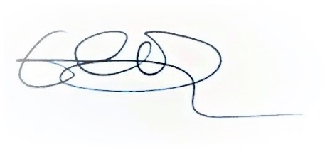
Emily Simpson
Clerk to the Council
5th July 2024

AGENDA
- Attendance and Apologies for Absence
To accept apologies for absence.
- To Receive Declarations of Interest, Notification of Changes to Members’ Interests and consider any requests for a dispensation
To receive any declarations of interests from Members in respect to items on the agenda.

- Public Session (members of the public may speak for up to 5 minutes at the discretion of the Chair about items on the agenda).

- Approval of the Minutes from the Council meeting held on 9th May 2024*
To review and approve.

- HALC Update
To receive an update from the Chair.

- Planning Applications
- Review any planning applications received since the publication of the agenda

- Planning Decisions from HDC
To receive decisions on planning applications from Horsham District Council.

Parish: Ashurst PC Application Number: DC/23/1979 Site: Stables at Glebe Meadow Church Lane Ashurst Steyning West Sussex BN44 3AR Description: Change of use of existing stable building into a holiday let, alongside building operations including the introduction of infill glazing and windows, together with the provision of parking and other associated works. Decision: Application Permitted Date of Decision: 08/05/2024

- Payments and bank reconciliation
- Review and approve the schedule of payments and bank reconciliation since the last meeting (9th May).*
- To consider a grant request of £350.00 from Air Ambulance Charity Kent Surrey Sussex.*

- Recreation Ground
- To receive a report on the Recreation Ground Trust’s income and expenditure since the last meeting (9th May).*
- To review 2024/25 contract and charge for Ashurst United Football Club to hire the Recreation Ground.*
- To receive an update on the rebuild/replacement of the John Eaton Hut.

- Correspondence

Next meeting date: 19th September at 7.30pm.

*Documents circulated with the agenda

