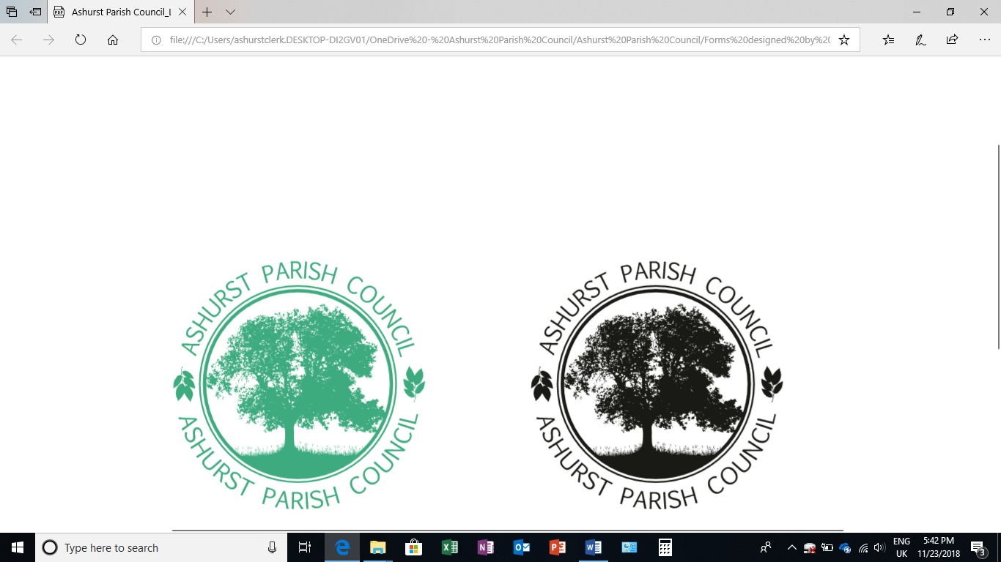 | Clerk to the Council: Emily Simpson  Tel: 07881714526  e-mail: ashurstclerk@outlook.com

MINUTES OF THE MEETING OF ASHURST PARISH COUNCIL, HELD AT ASHURST VILLAGE HALL ON THURSDAY 16th JANUARY 2025 AT 7.30PM
Attendance:
Chairman | Cllr Fischel
Ashurst Parish Council (APC) | Cllrs Knight, Nicholson and Russell (Vice Chair)
Horsham District Council (HDC) | District Cllrs Victoria Finnegan and Nicholas Marks
Clerk | Emily Simpson
Public | There were none

- Attendance and Apologies for Absence
There were none.
- To Receive Declarations of Interest, Notification of Changes to Members’ Interests and consider any requests for a dispensation
Councillor Russell declared an interest in planning application DC/25/0013.
- Public Session (members of the public may speak for up to 5 minutes at the discretion of the Chair about items on the agenda)
There were no members of the public.

- Approval of the Minutes from the Council meeting held on 14th November 2024
Councillors RESOLVED to approve the minutes from the last meeting as a true and accurate record.
- District Councillor Reports
District Councillor Victoria Finnegan gave a summary of what is known so far regarding the joint devolution bid from East Sussex County Council, West Sussex County Council and Brighton & Hove Council to become a unitary authority and create one strategic district. In theory, parish and town councils would have the opportunity to take on more responsibilities. The County Council elections for May 2025 were scheduled to proceed as planned but there was a chance these could be postponed.

Regarding the Local Plan, the Inspector had cancelled all future hearings due to a number of issues including duty to co-operate, water neutrality and access to SNOWS (Sussex North Offsetting Water Scheme). HDC Officers had already responded to the 22 action points and still consider the Plan to be sound, but they were waiting for the Inspector to comment.

It was also noted that there had been a change of approach to water neutrality at HDC whereby planning applications could now be granted subject to a ‘Grampian’ style condition restricting the commencement of development until the applicant had secured either an offset via the Local Authority SNOWS credit scheme, or a bespoke water neutrality scheme to which HDC had agreed.

The District Councillor also reported that the Cabinet had agreed to work with Fields of Trust to consider the viability of placing Horsham Park into a Fields of Trust. Other items to note were a new car-sharing app launched by WSCC (details on the WSCC website) as well as information on the Nature Recovery Award which had a deadline of early March.

- Conservation and Biodiversity Initiatives
Councillor Knight said the report from the Sussex Biodiversity Record Centre had been received and showed that the local area was rich in flora and fauna. He was in touch with Steve Tilman from Sussex Wildlife Trust who hopefully would visit the area in the Spring to help devise a plan on what could be done to increase biodiversity.

The Chair suggested we think of someone with ‘biodiversity’ credentials to come and talk at the Parish Annual Meeting. Councillor Knight would come back with some ideas.

A conversation ensued about waste in the area, including fly tipping, and recycling and how best to signpost residents on where to recycle certain items, such as crisp packets. The Chair suggested that another Village Clean Up day would be a good idea. March 16th was provisionally agreed on.

- HALC update
The Chair reported that the HALC meeting was scheduled to take place this evening but the Clerk would share the minutes from this meeting once they had been circulated.

- Planning applications
- To discuss any planning applications received since the publication of the agenda

DC/25/0013 Otters Church Lane Ashurst West Sussex
Demolition of existing side garage and conservatory and the erection of a single storey side extension. Replacement windows to all elevations.
After consideration, Councillors RESOLVED to remain neutral.

- Planning Decisions from HDC
Application Number: DC/24/1751
Site: Campions Bines Green Partridge Green Horsham West Sussex RH13 8EH
Description: Demolition of existing conservatory and erection of a single storey side extension. Decision: PERMITTED
Date of Decision: 06/01/2025

Councillors noted the above decision.
- Planning Appeals

DC/24/0180 Ford Farm Ford Lane Ashurst West Sussex BN44 3AT
Description of Application: Change of use from 3 farm buildings to B8 storage (Retrospective).

Councillors noted the above planning appeal.

- Payments and bank reconciliation
- Councillors RESOLVED to approve the schedule of payments and bank reconciliation since the last meeting (14th November 2024). (See Appendix 1.)

12. Budget
After consideration, Councillors RESOLVED to approve the draft budget for 2025/26 resulting in a precept request of £14,660. (See Appendix 2.)

- Recreation Ground
- The Clerk had previously circulated a report on the Recreation Ground Trust’s income and expenditure, which Councillors RESOLVED to approve. (See Appendix 3.)
- It had been noted that the rubber tiles in the playground should be cleaned and Councillor Russell said he would do this in the Spring.
- Following the last meeting, the Chair had received revised plans for the proposed new sports building from the architect, but they were still not what Councillors had envisaged or discussed. The Chair said the plans were almost double the size of what had been drawn up so it was AGREED that an informal meeting would take place to further discuss requirements and hopefully more accurate plans would be available for the next meeting. As previously discussed, a public consultation would then follow.

- Speeding in Ashurst
- There was no Speedwatch update but anyone interested in joining should contact the Clerk.
- Councillor Nicholson said a response had been received from WSCC regarding the sitings of the poles for the proposed SID and a number of suitable locations had been identified. Councillors needed to agree these final locations.
Ideally, there would be four poles in total and WSCC said once the sites were agreed, the 28 days’ notices would go up and, if no objections were received, a licence would be issued. The Parish Council would be liable for the installation and maintenance of the poles.
- Councillor Nicholson was looking into this and would report further at the next meeting.

- Recruitment
The Clerk informed the Council that the vacancy had been advertised with WSALC and the Ashurst Parish Council website. Expressions of interest had already been received and further details would be shared after the closing date of 31st January.
- GDPR
Councillors were reminded to delete emails over 6 months old.

- Meeting dates
The next meeting was scheduled to take place on 20th March at 7.30pm.

Appendix 1
Bank reconciliation
Balance per bank statement
Closing balance 31st December 2024 | 20,549.22
Add: outstanding receipts | 0.00
Less: outstanding payments
Net balances | 20,549.22
Cashbook (balance as of 1st April 2024) | 14,260.51
Add receipts (from 1st April - 31st March 2025) | 14,529.81
Less payments (from 1st April - 31st March 2025) | 8,241.10
Net balance | 20,549.22

Schedule of payments since the last meeting (14th November)
25.11.24 | Ashurst Church | Grant | £100.00
25.11.24 | E Simpson | Backdated pay to 1st April 2024 | £97.65
25.11.24 | Air Ambulance Charity | Grant | £50.0
17.12.24 | E Simpson | Salary November 2024 | £265.75
17.12.24 | E Simpson | Office Allowance November 2024 | £13.33
 |  |  | £526.73

Income received since the last meeting (14th November)
There was none.

Appendix 2
Budget 2025/26
BUDGET | 2025/26
Income
Precept | £14,660
VAT
TOTAL | £14,660
BUDGET 2025-26
PWLB (Village Hall) | 2,724.38
Insurance (including rec) | 478.57
Village Hall Hire | 250
Donation for dog show (nominal) | -250
WSALC subscription | 97.95
HALC subscription | 20
Parish Online subscription | 0
Grants (rec ground) | 5,000
Grant mini bus | 50
Grant to Air Ambulance | 100
Other grants | 400
Audit (internal) | 200
Office 365 | 136.22
Internet hosting | 154.19
Admin expenses | 95
Clerks salary | 4,189
Courses & training | 250
Travel allowance & expenses | 50
Chairmans allowance | 50
Office allowance | 180
Green Initiatives | 350
Newsletter contribution | 100
Data protection (ICO) | 35
 | £14,660

Appendix 3
Recreation Ground Account
The balance as of 31st December 2024 was £11,615.87.
Income received since the last meeting on 14th November 2024
£375 was received on behalf of Ashurst United Football Club on the 14th November 2024 in relation to rental of the Recreation Ground.
Expenditure since the last meeting to 31 December 2024 totals £864.25 and comprises:
HDC | Playground inspections April – Sep 2024 | £86.40
G A Hedley | Hedge cutting | £125
EDF | Electricity | £60
Sussex Land Services | Grass cutting - 2024 | £282.85
Wicksteed | Annual playground inspection | £180
Business Stream | Water rates | £70
EDF | Electricity | £60

The Parish Council is yet to pay the grant of £5,000 to the Recreation Ground but has paid for the G E Paul invoice which was £2,160, leaving a further £2,840 to be transferred before the end of the financial year. The bench for the recreation ground is due to paid for imminently and will also be paid for from this grant.

